**TABLE OF CONTENTS**

**PAGE NO**

**Bonafide.................................................................................................................................i**

**Abstract.....................................................................................................iii**

**List of Tables............................................................................................vii**

**List of Figures .........................................................................................viii**

**Chapter 1: Introduction**

* 1. **About Organization..................................................................1**

**Chapter 2: Requirement Analysis**

**2.1 Problem Definition....................................................................5**

**2.2 Introduction...............................................................................6**

**2.2.1 Overview.................................................................................7**

**2.3 Objective/Purpose....................................................................8**

**2.4 Functional Requirements........................................................9**

**2.5 Non Functional Requirements................................................11**

**2.6 Data Flow Diagrams................................................................12**

**2.6.1 Definition.................................................................................12**

**2.6.2 Level 0......................................................................................14**

**2.6.3 Level 1.....................................................................................15**

**2.6.4 Level 2.....................................................................................17**

**2.7 Entity Relationship Diagram..................................................20**

**2.7.1 ER Diagram............................................................................21**

**2.7.2 ER Diagram Description.......................................................22**

**Chapter 3: Database Design**

**3.1 Table Design...........................................................................24**

**Chapter 4: Platform Used**

**4.1 Hardware Interface............................................................30**

**4.2 Software Interface..............................................................30**

**4.3 Client & server side Requirements...................................31**

**Chapter 5: System Design**

**5.1 Module Description...........................................................36**

**5.1.1 Module 1: Login...............................................................36**

**5.1.2 Module 2: Administrator................................................36**

**5.1.3 Module 3: User.................................................................43**

**Chapter 6: System Testing**

**6.1 Test Cases and Test Results.............................................48**

**Chapter 7: Conclusion**

**7.1 Conclusion........................................................................55**

**7.2 Future Scope....................................................................56**

**7.3 Limitation.........................................................................57**

**APPENDICES.....................................................................................58**

**APPENDIX-A: CODING...................................................................59**

**APPENDIX-B: SNAPSHOTS.............................................................69**

**REFERENCES.....................................................................................100**

**LIST OF TABLES**

|  |  |  |
| --- | --- | --- |
| **Table No.** | **Description** | **Page No.** |
| 3.1 | Post Requirement | 24 |
| 3.2 | Registration | 25 |
| 3.3 | List Property | 26 |
| 3.4 | Admin | 27 |
| 3.5 | Message | 28 |
| 3.6 | Projects | 29 |
| 6.4.1 | Test case I Login | 52 |
| 6.4.2 | Test Case II Create New User | 53 |
| 6.4.3 | Test Case III List Property | 54 |

**LIST OF FIGURES**

|  |  |  |
| --- | --- | --- |
| **Figure No.** | **Description** | **Page No.** |
| 2.1 | DFD Level 0 | 14 |
| 2.2 | ADMIN DFD Level | 15 |
| 2.3 | USER DFD Level 1 | 16 |
| 2.4 | ADMIN Edit Project Detail DFD Level 2 | 17 |
| 2.5 | ADMIN Edit Property Detail DFD Level 2 | 18 |
| 2.6 | ADMIN Edit User Detail DFD Level 2 | 19 |
| 2.7.1 | ER Diagram | 21 |
| Figure 1 | Main Page | 69 |
| Figure 2 | Residential Properties | 70 |
| Figure 3 | Commercial Properties | 71 |
| Figure 4 | Projects | 72 |
| Figure 5 | User Registration | 73 |
| Figure 6 | Property Details | 74 |
| Figure 7 | User Login | 75 |
| Figure 8 | User Profile | 76 |
| Figure 9 | List Property | 77 |
| Figure 10 | Post Requirements | 78 |
| Figure 11 | Send Message | 79 |
| Figure 12 | View Message | 80 |
| Figure 13 | Change Password | 81 |
| Figure 14 | Search Properties and projects | 82 |
| Figure 15 | Admin Login | 83 |
| Figure 16 | Admin Menu | 84 |
| Figure 17 | Admin Profile | 85 |
| Figure 18 | Admin Change Password | 86 |
| Figure 19 | Admin Send Message | 87 |
| Figure 20 | Admin View Message | 88 |
| Figure 21 | Admin View Users | 89 |
| Figure 22 | Admin Add users | 90 |
| Figure 23 | Update user details | 91 |
| Figure 24 | Delete user | 92 |
| Figure 25 | Admin can View Residential Properties | 93 |
| Figure 26 | Admin Can View Commercial Properties | 94 |
| Figure 27 | Admin Can View Projects | 95 |
| Figure 28 | Admin Verify Property | 96 |
| Figure 29 | Admin Can Add Project | 97 |
| Figure 30 | Admin Can Add Property | 98 |
| Figure 31 | Admin Can Delete Project | 99 |

**APPENDIX-B**

**SNAPSHOTS**

**Main page**

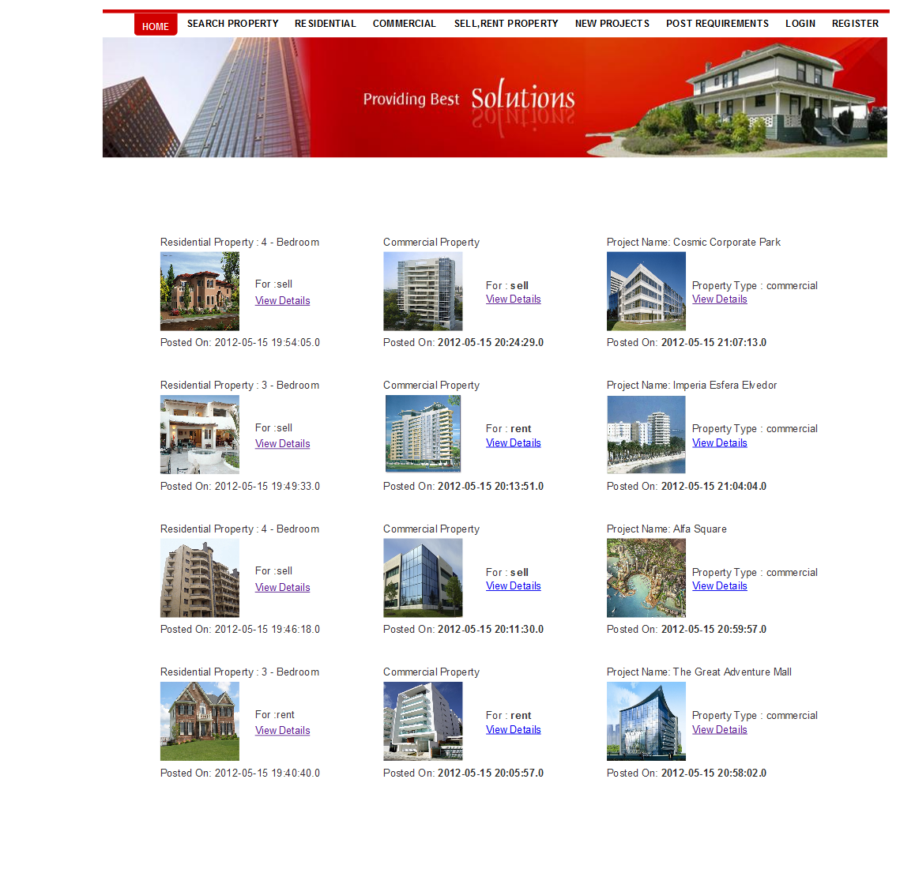

**Figure 1 Main Page**

**Residential Properties**

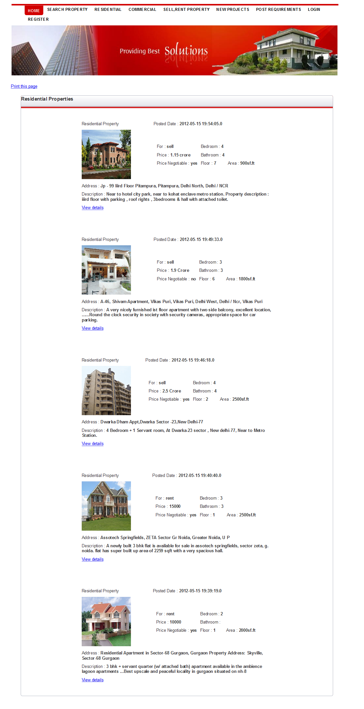 **Figure 2 Residential Properties**

**Commercial Properties**

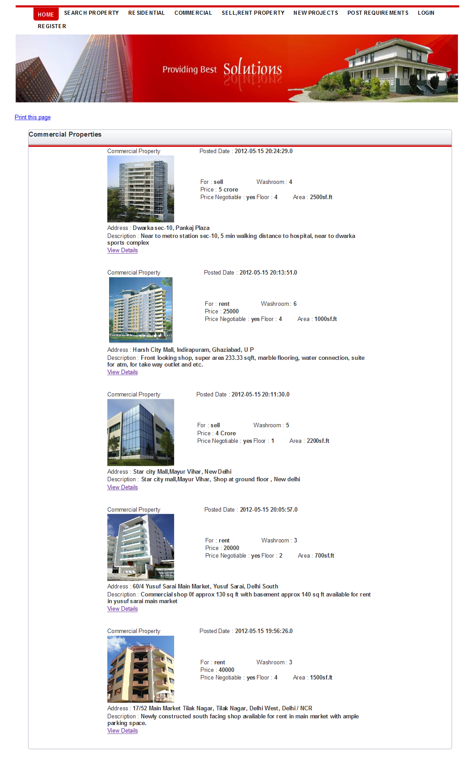

**Figure 3 Commercial Properties**

**Projects :**

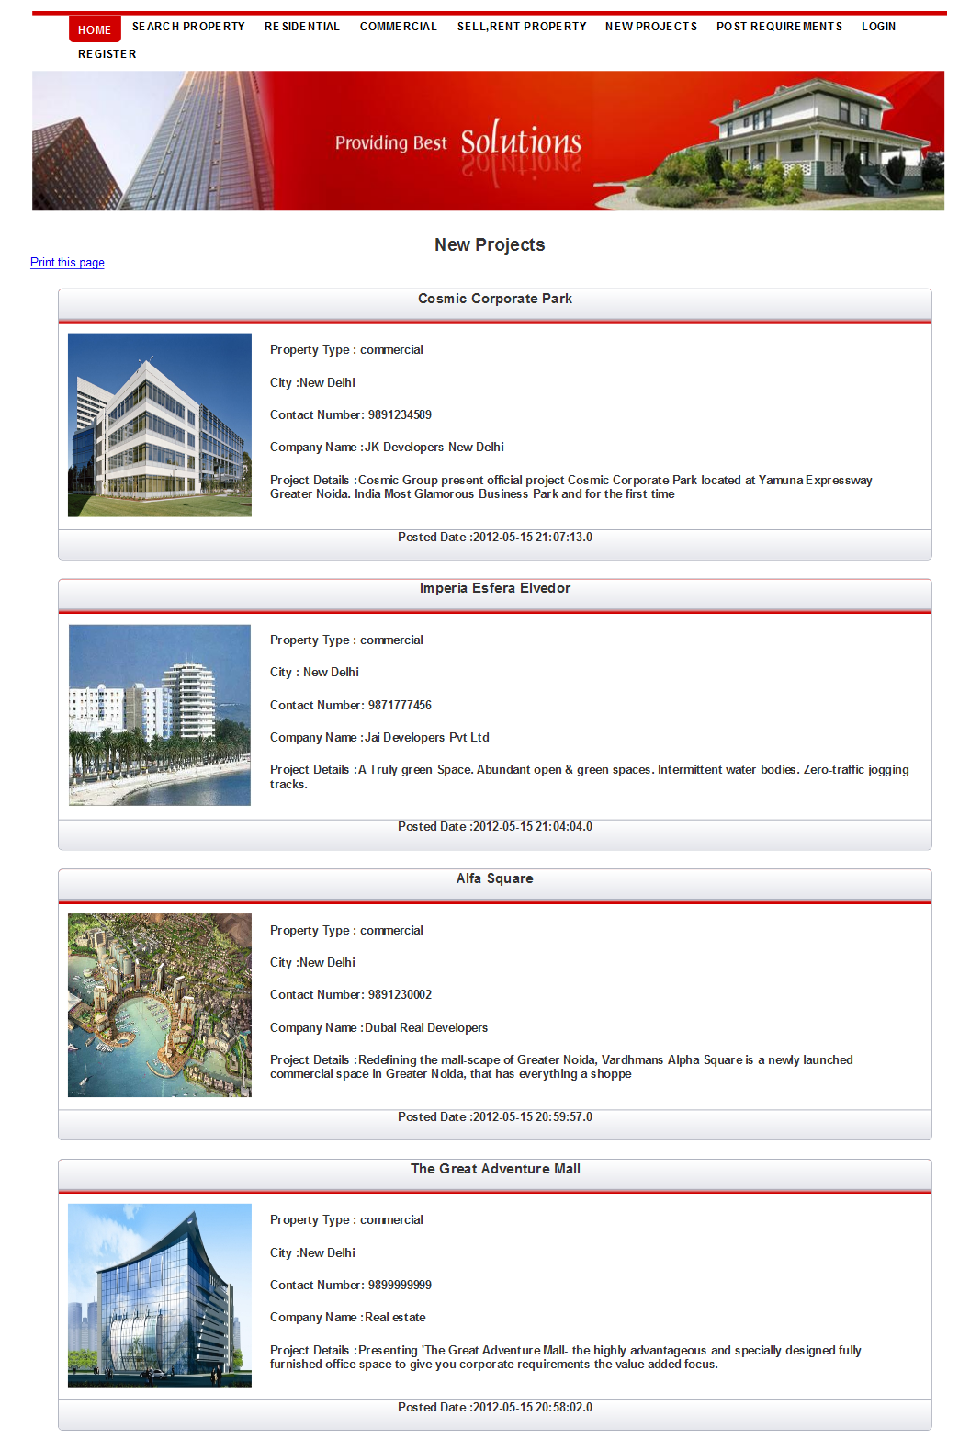

**Figure 4 Projects**

**Registration Page**

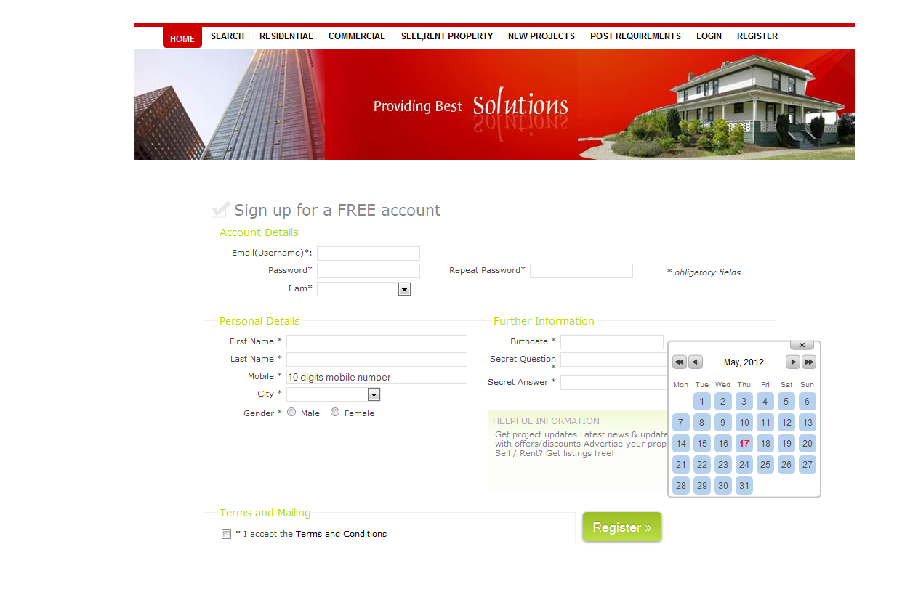

**Figure 5 User Registration**

**Property Details :**

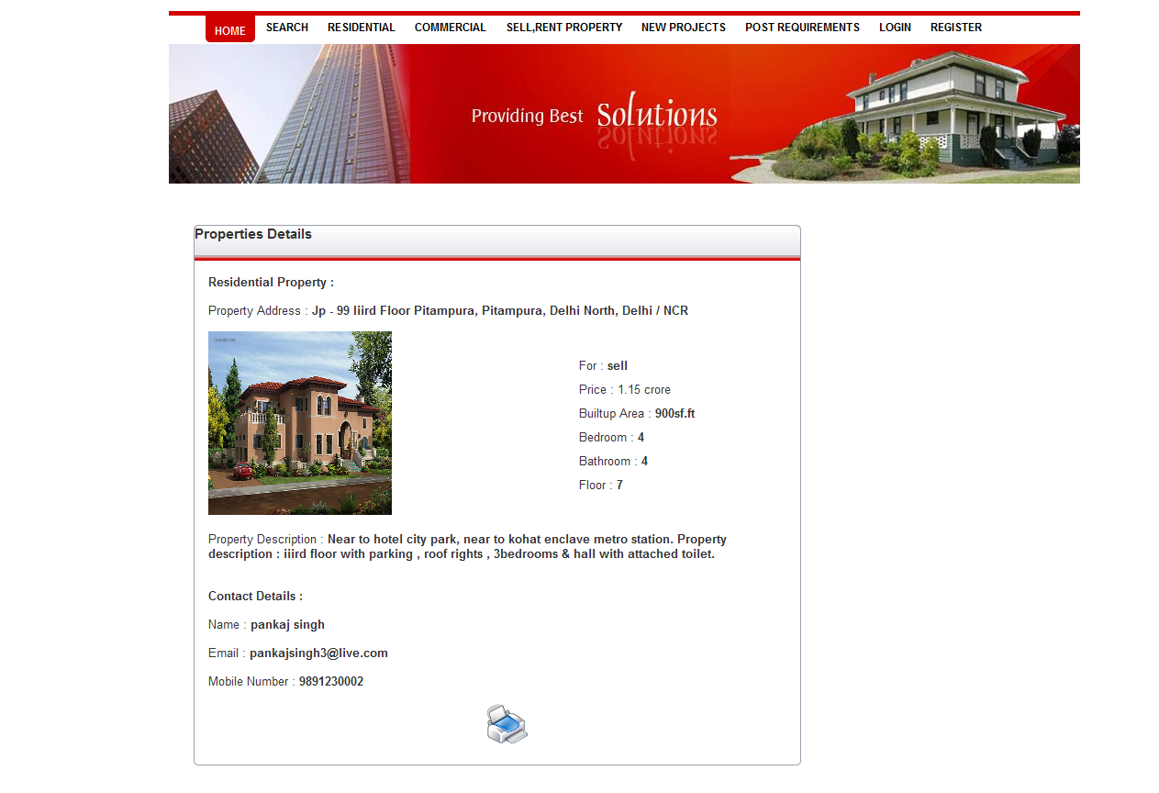

**Figure 6 Property Details**

**User Login :**

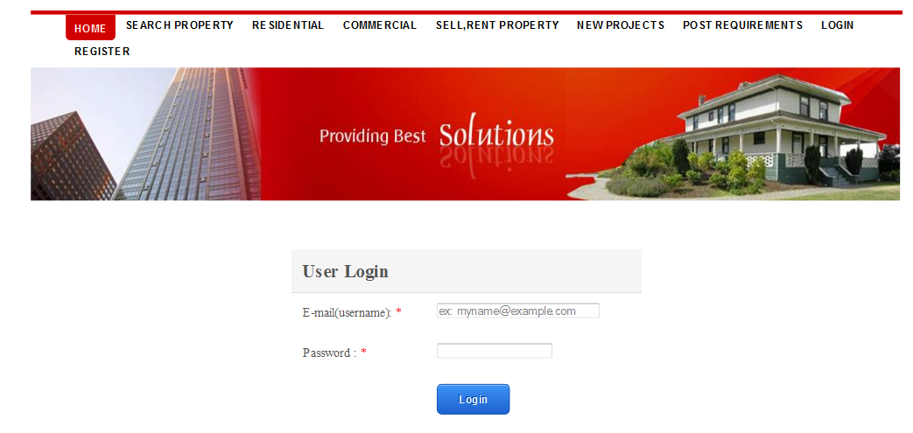

**Figure 7 User Login**

**User Profile**

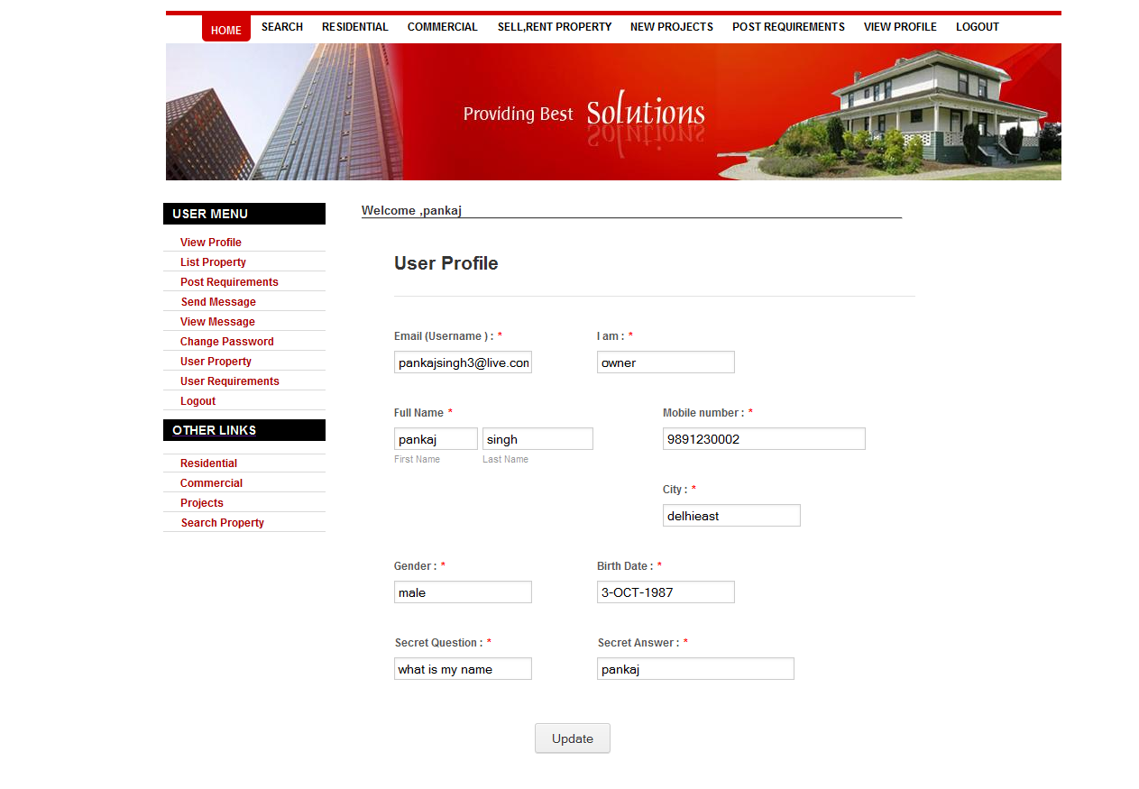

**Figure 8 User Profile**

**List Property**

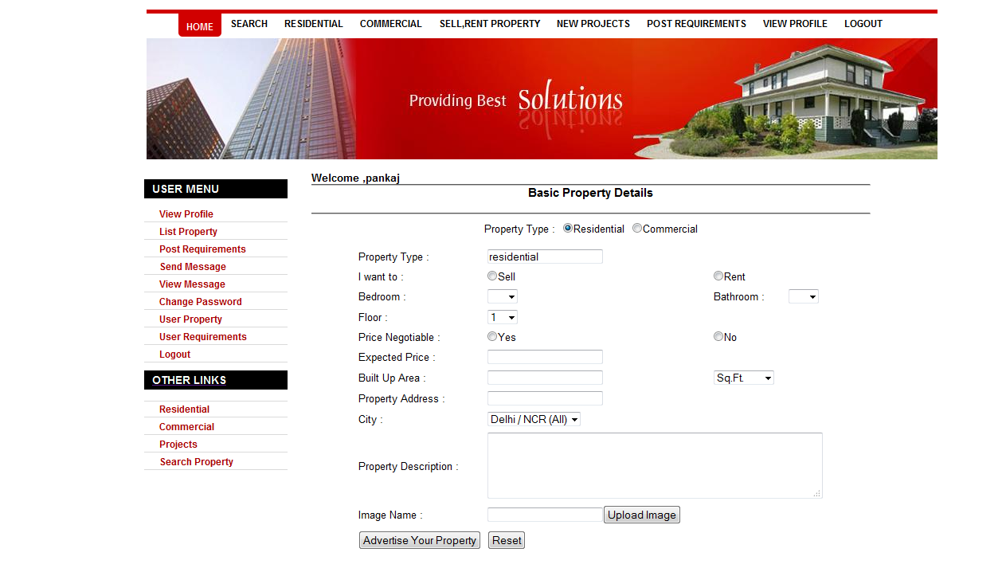

**Figure 9 List Property**

**Post Requirements :**

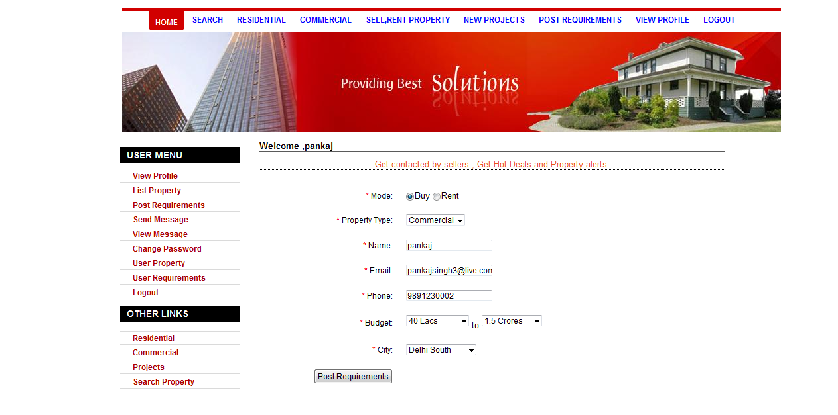

**Figure 10 Post Requirements**

**Send Message**

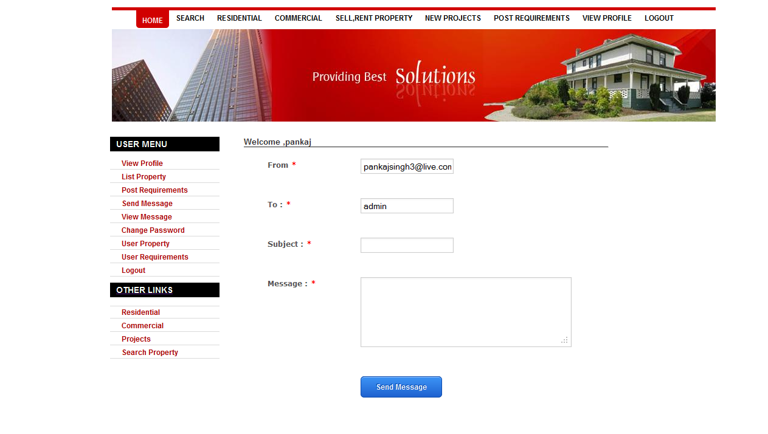

**Figure 11 Send Message**

**View Message** :

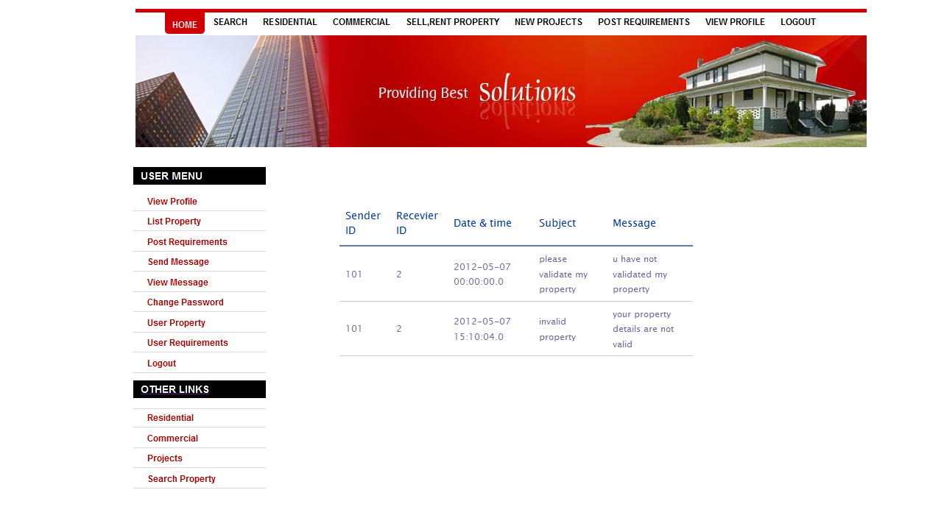

**Figure 12 View Message**

**Change Password** :

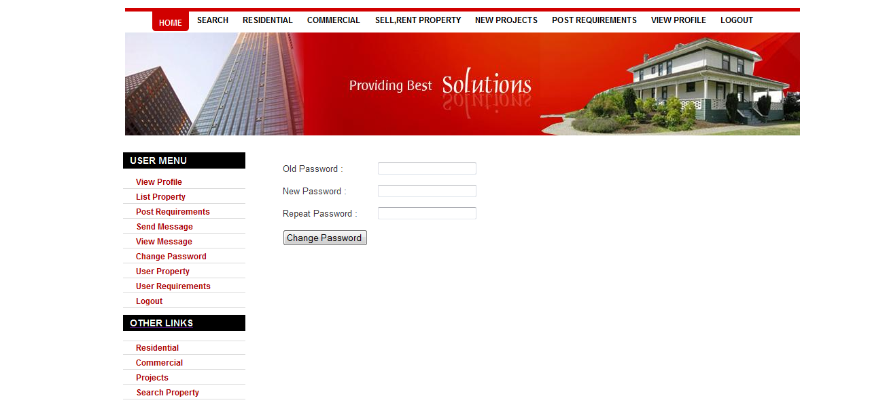

**Figure 13 Change Password**

**Search Property & Projects** :

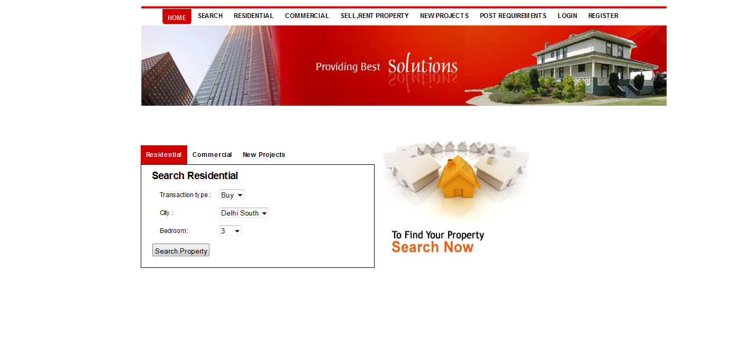

**Figure 14 Search Property and projects**

**Admin Login** :

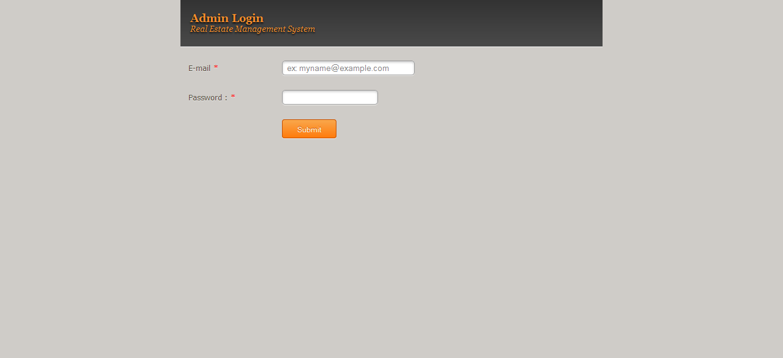

**Figure 15 Admin Login**

**Admin Menu** :

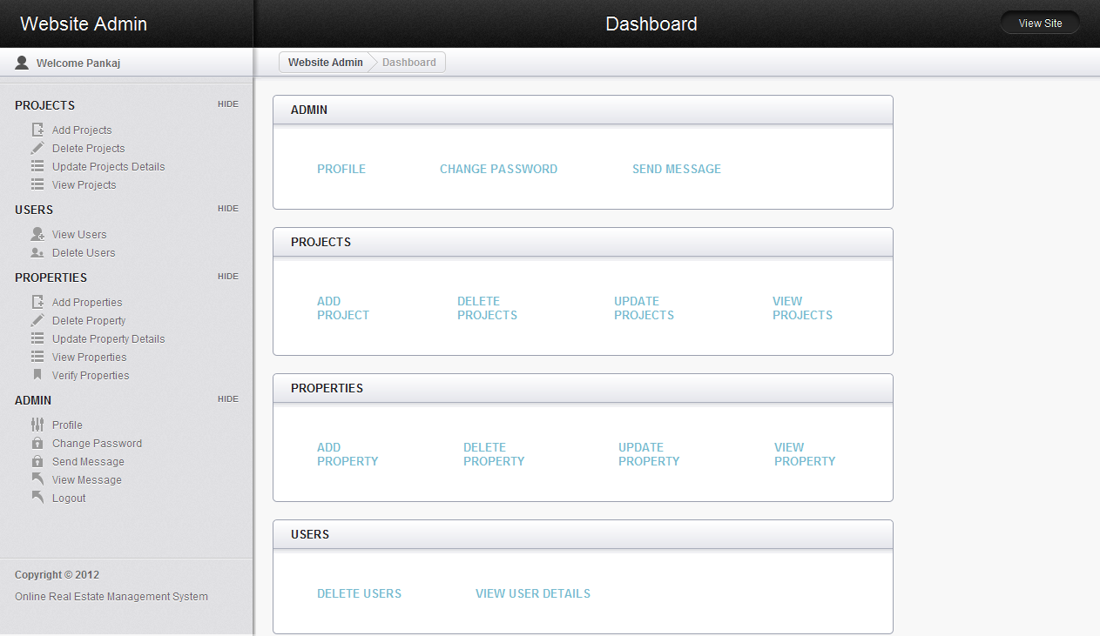

**Figure 16 Admin Menu**

**Admin Profile** :

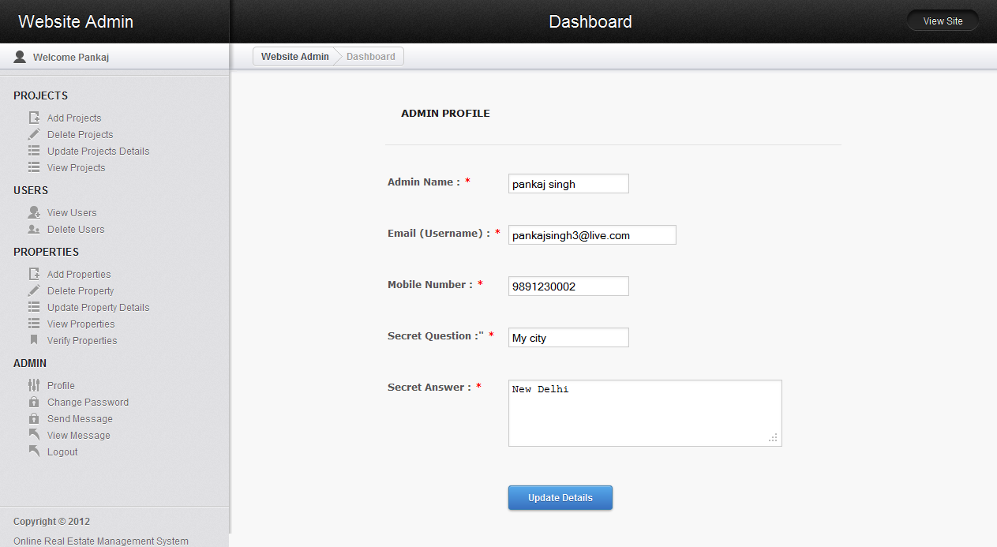

**Figure 17 Admin Profile**

**Change Password** :

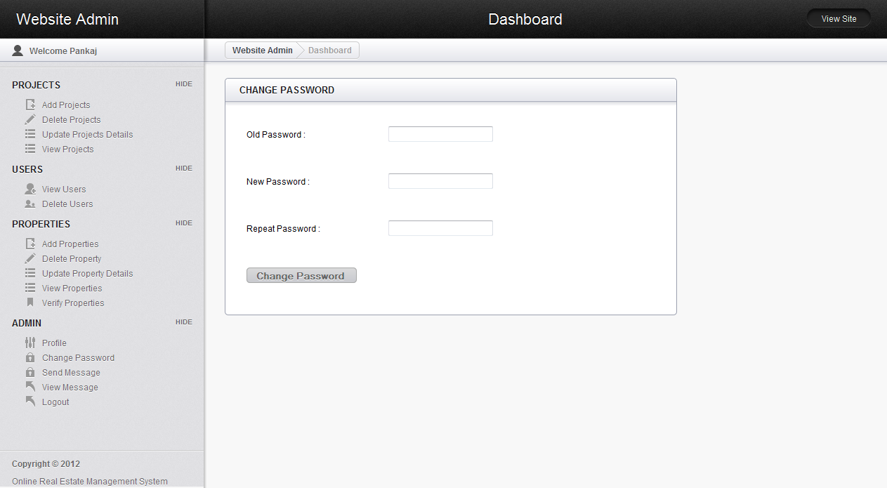

**Figure 18 Admin Change Password**

**Send Message** :

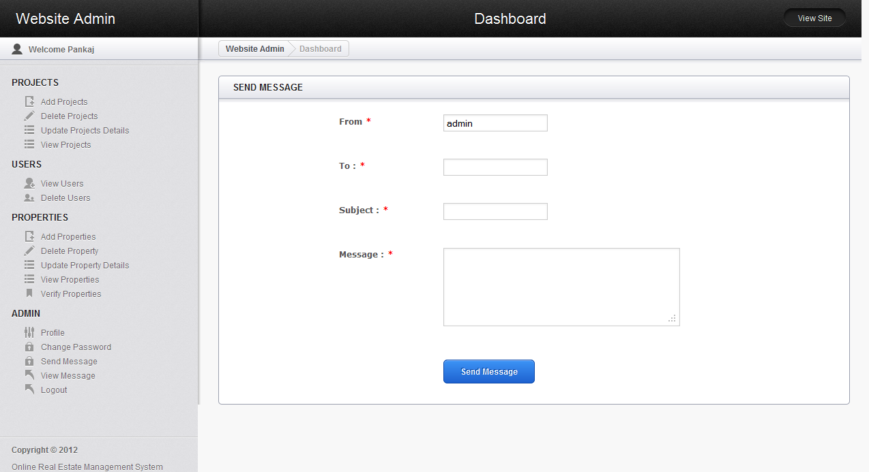

**Figure 19 Send Message**

**View Message** :

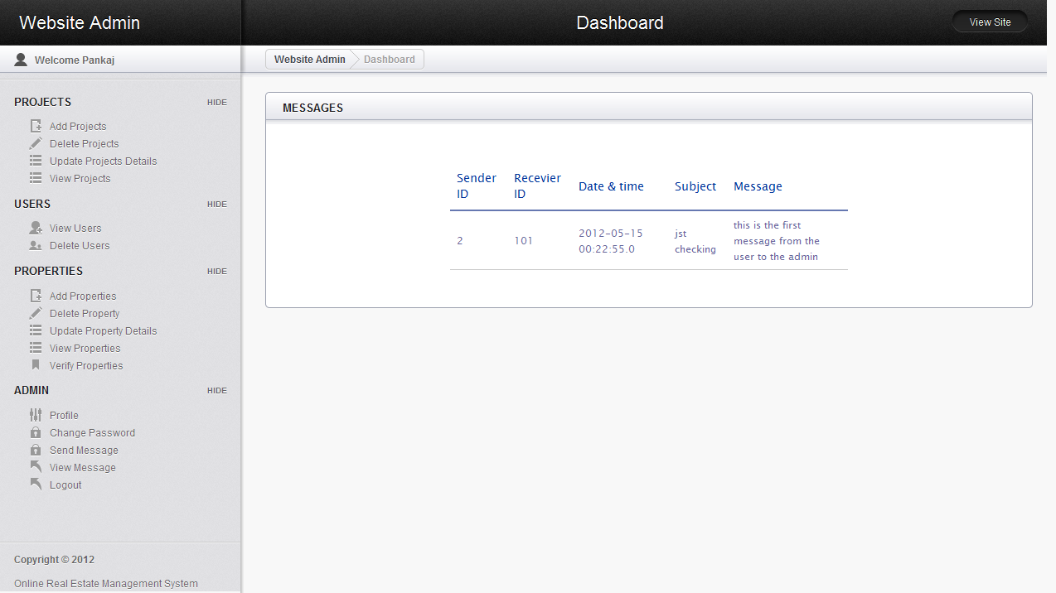

**Figure 20 View Message**

**View Users** :

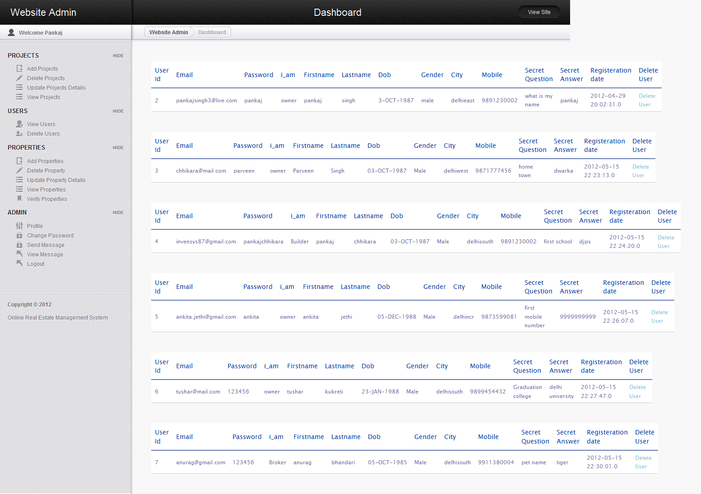

**Figure 21 View Users**

**Add New User :**

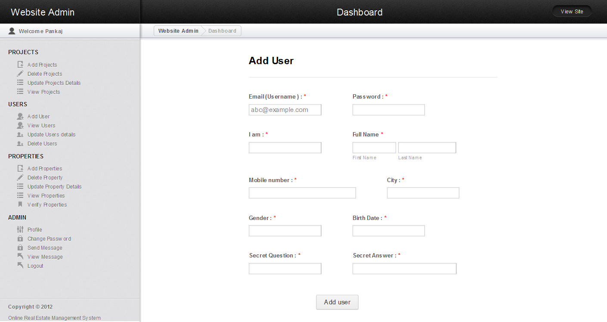

**Figure 22 Add New User Update User Details :**

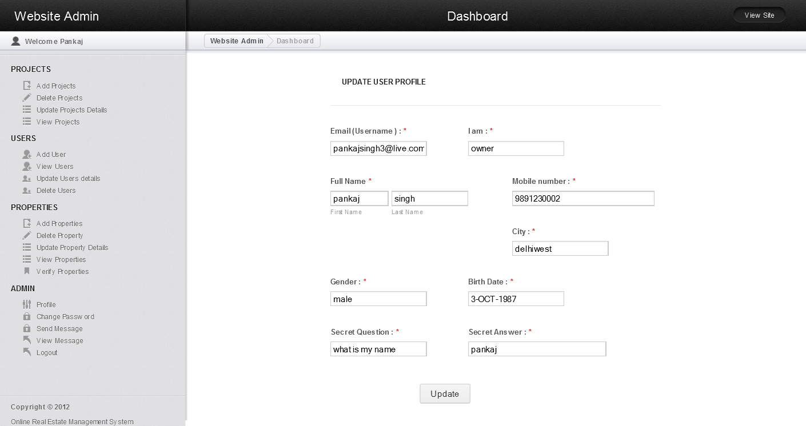

**Figure 23 Update User details**

**Delete User :**

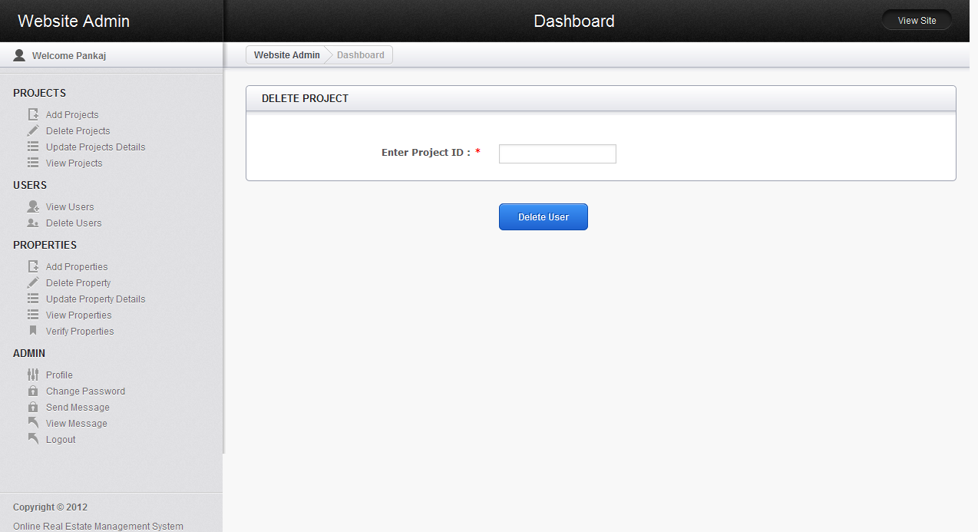

**Figure 24 Admin Can Delete A User**

**View Residential Property** :

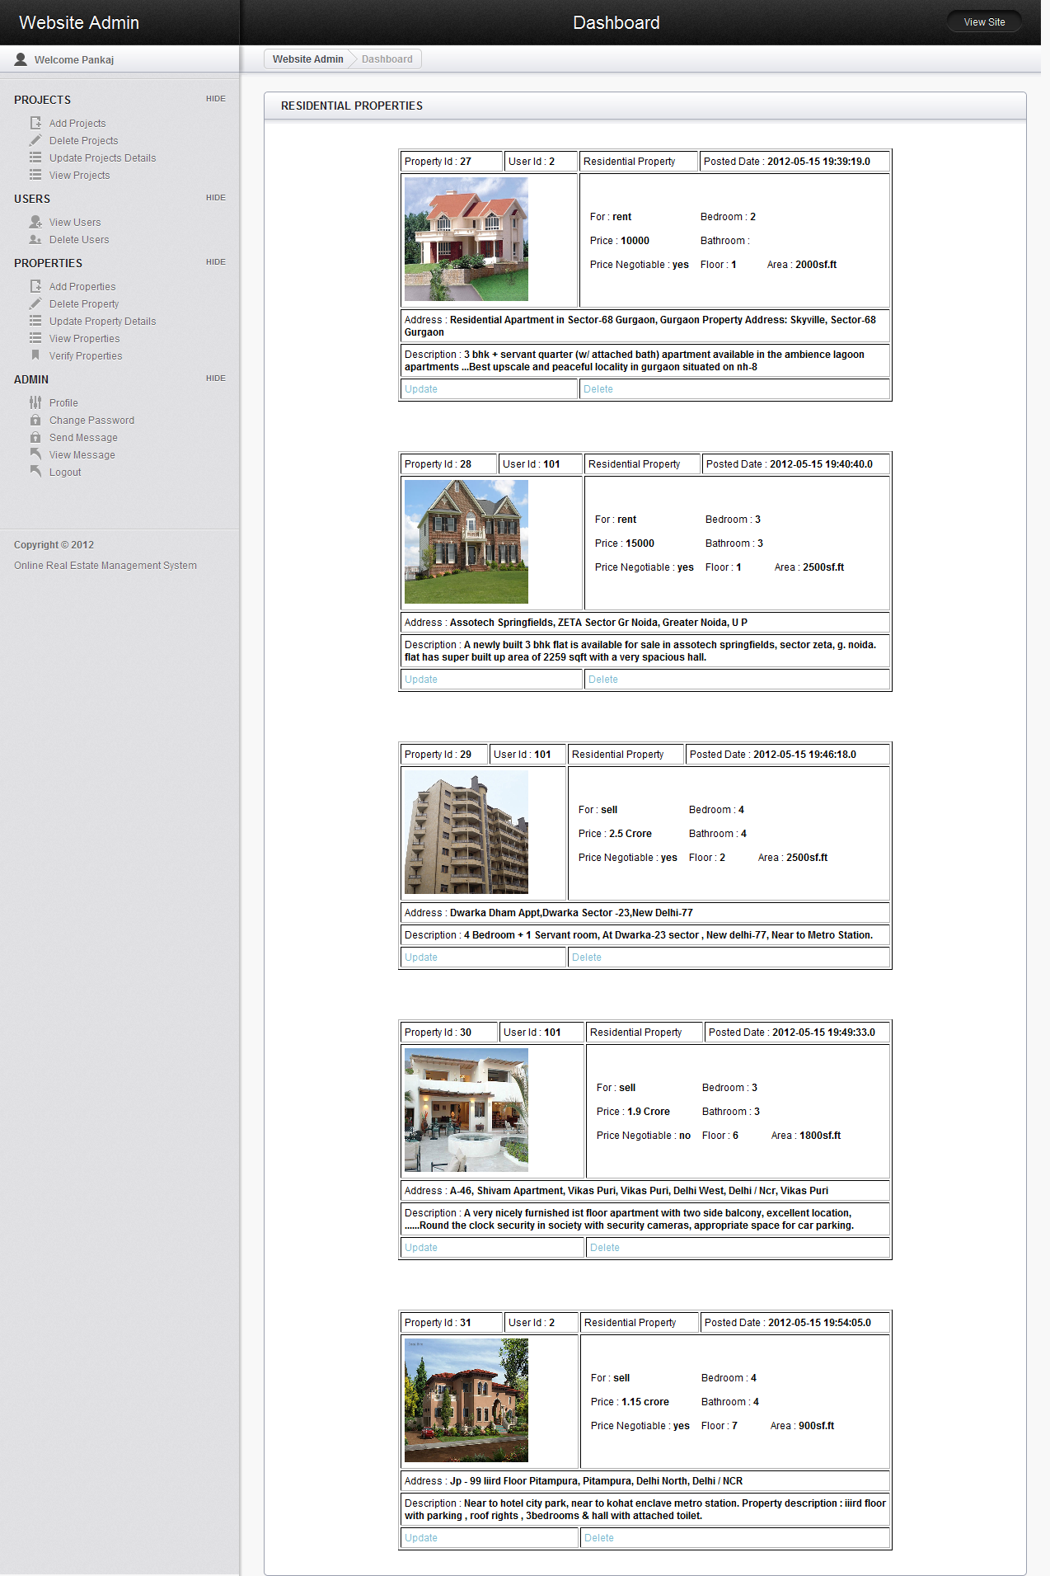

**Figure 25 Admin can View Residential Property**

**View Commercial Property** :

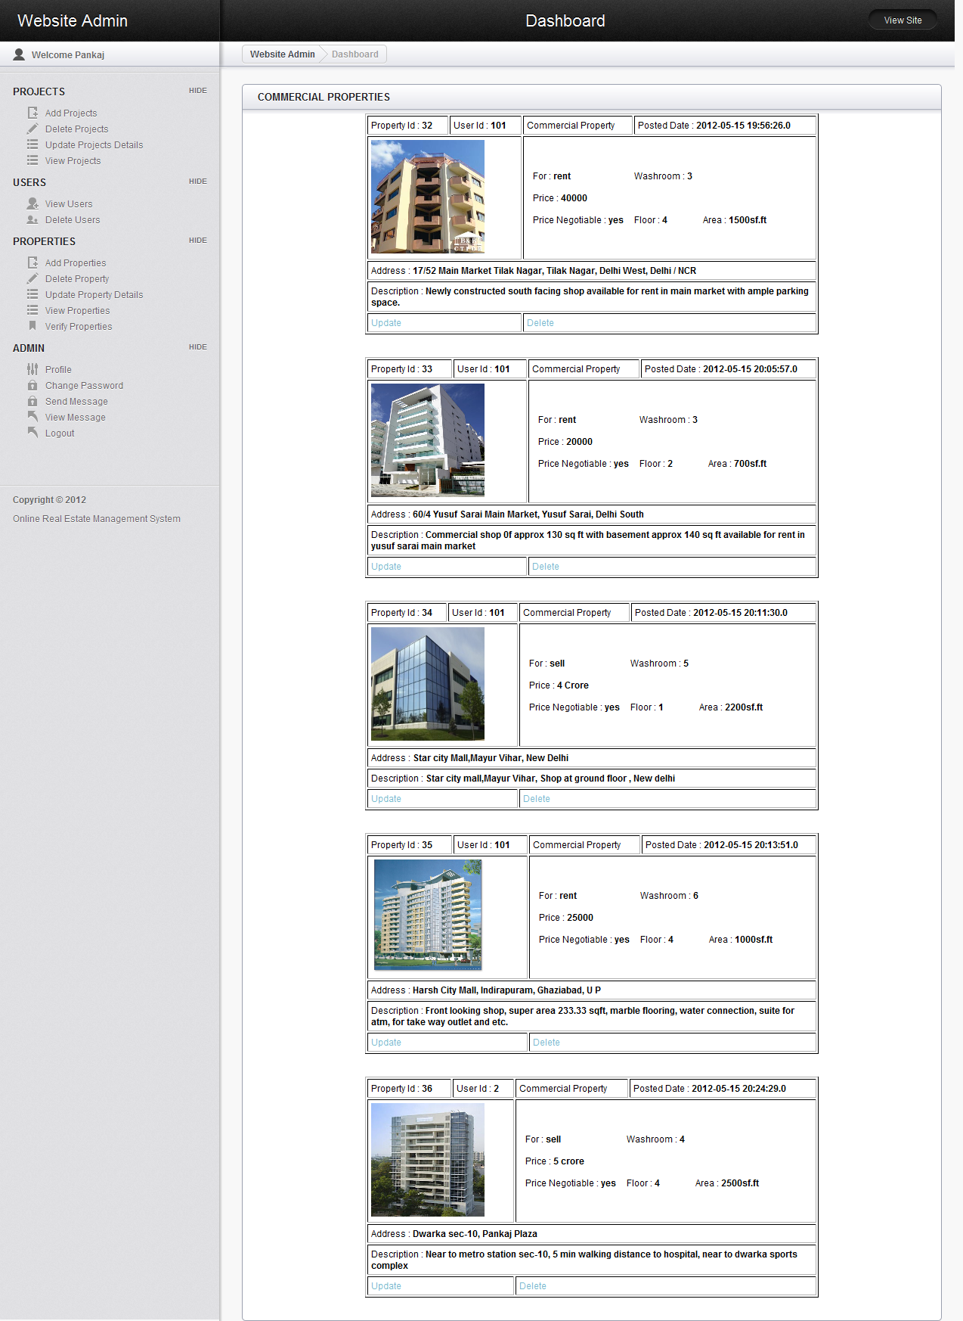

**Figure 26 Admin can View Commercial Property**

**View Projects :**

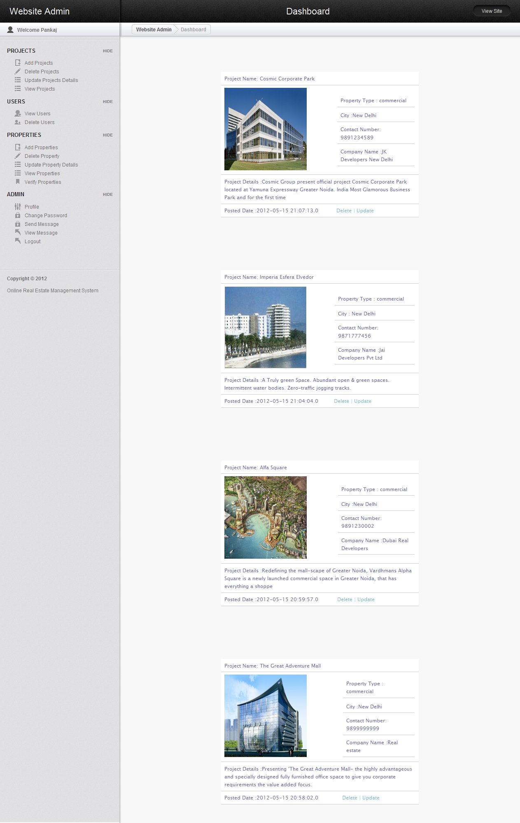

**Figure 27 Admin can view Projects**

**Verify Properties** :

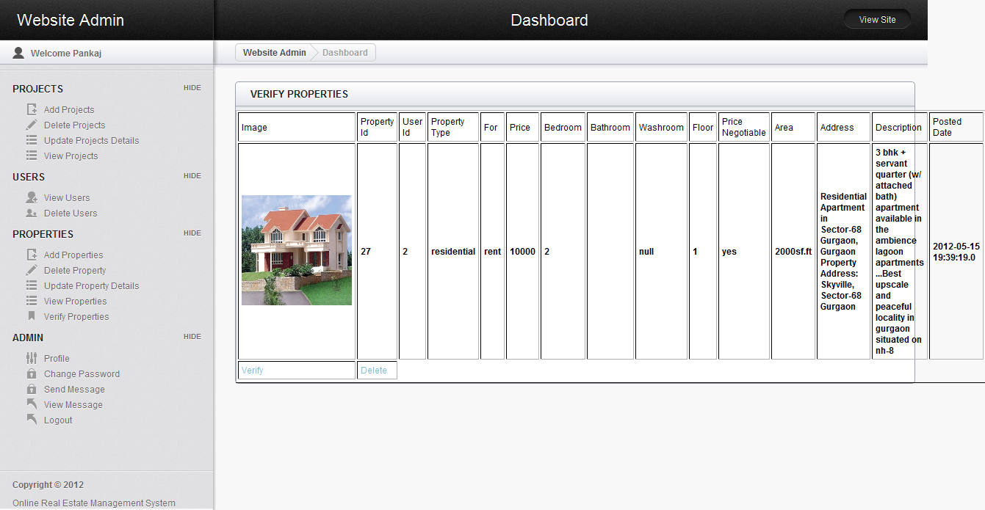

**Figure 28 Admin can Verify Properties**

**Add Projects** :

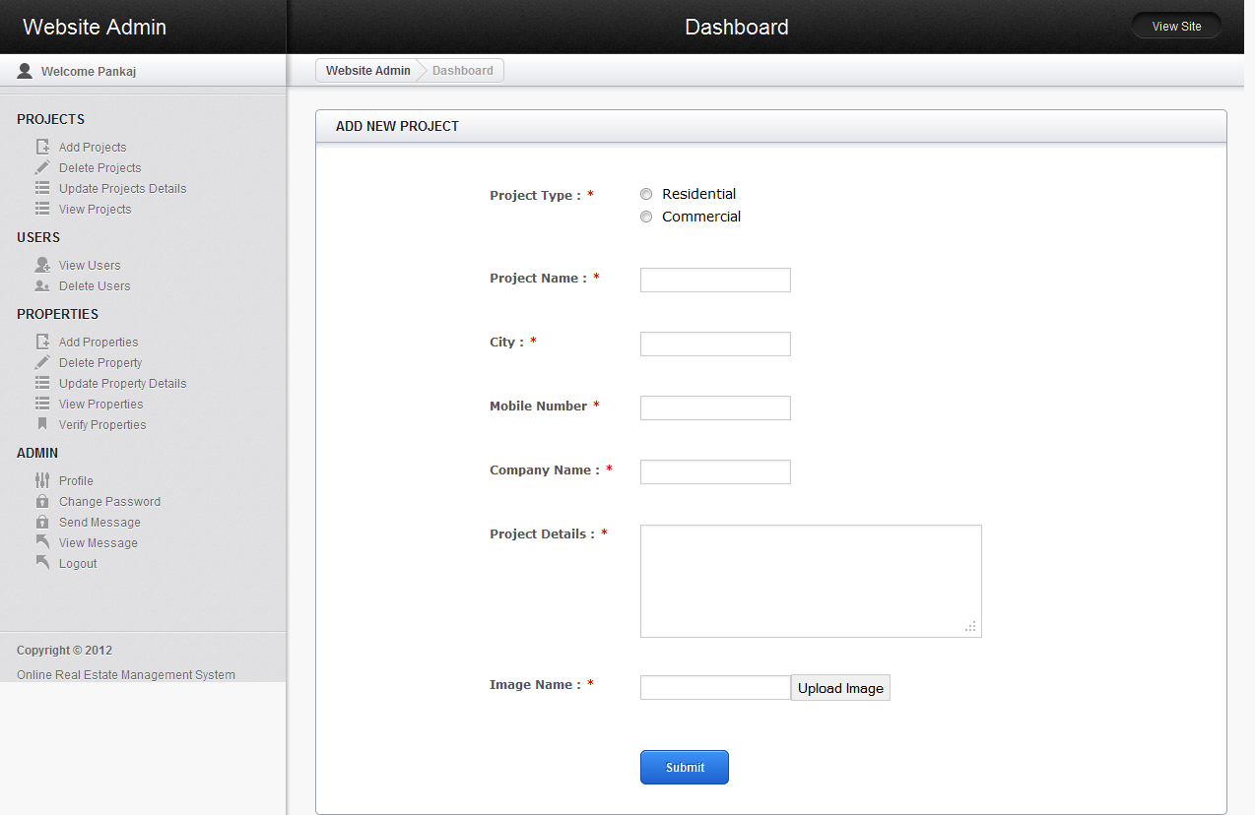

**Figure 29 Admin can Add Projects**

**Add Property** :

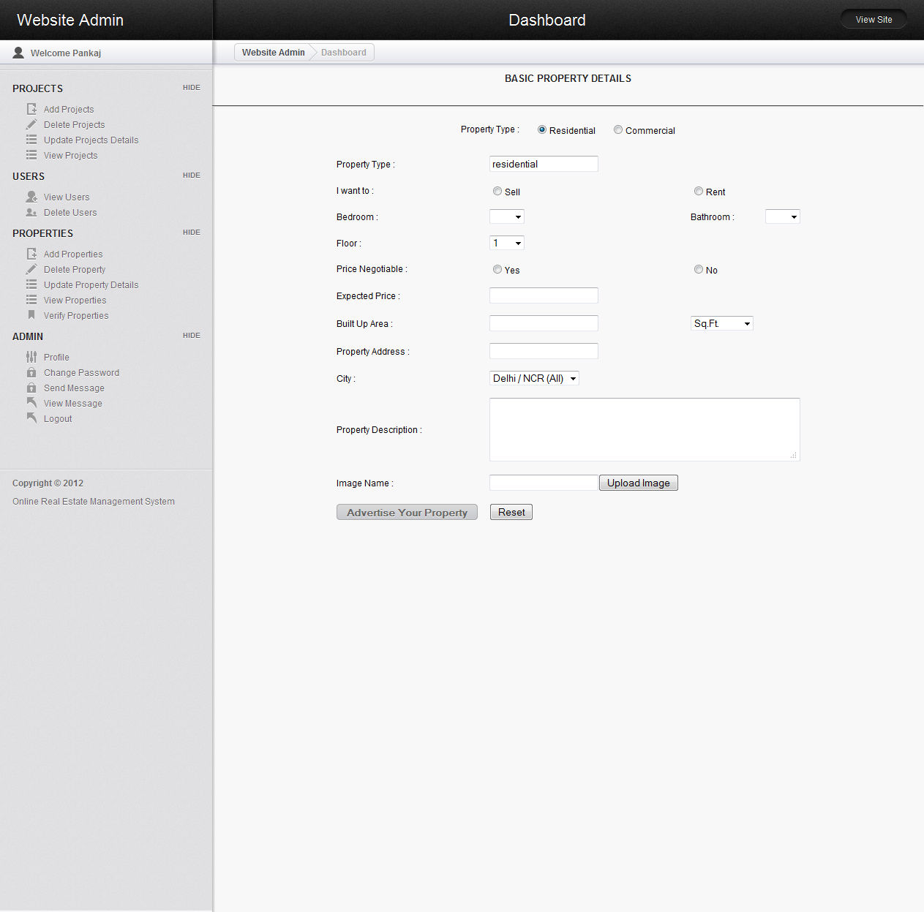

**Figure 30 Admin can Add Property**

**Delete Project** :



**Figure 31 Admin can Delete Projects**